

CSE 523 Machine Learning

Progress Report - 5

Section 1

Date of Submission: 16th March 2022

Group Name: **Bug Smashers**

Group Details

| Roll No | Name |
| --- | --- |
| AU1940028 | Moksh Doshi |
| AU1940120 | Jaimik Patel |
| AU1940130 | Nandish Patel |
| AU1940164 | Jenil Bagadiya |

2022 Winter Semester

# Tasks Performed in the week

* + Applied logistic regression algorithm to the processed dataset
  + Researched various dimensionality reduction algorithms to be applied in order to further improve the accuracy of the machine learning model
  + Explored various metrics to judge the performance of the machine learning model

# Outcomes of the tasks performed

* + Logistic Regression algorithm resulted in an accuracy of of 72.9% which is marginally higher than that of KNN with K=100 i.e. 71%
  + 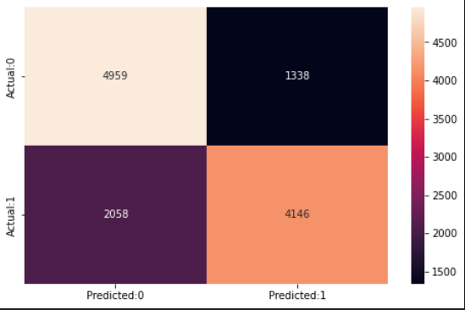
  + 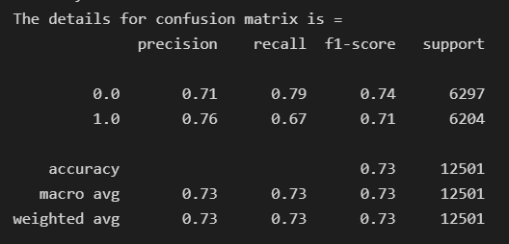

For logistic regression model

# Tasks to be performed in the upcoming week

* + Rerun both of the algorithms done yet i.e. KNN and Logistic Regression after doing feature selection (p-values)
  + Implementation of another classification algorithm i.e. naive bayes